 

Software requirement specification document for project Orphan Charity Organization

Mahmoud Ahmed

Yahya Salah Abdelhameed

Ali Mohamed  
  
Abdelrahman Nabil

Kirolos Refaat

Supervised by: Dr. ......

October 24, 2019

# Introduction

## Purpose of this document

The purpose of the document for an orphan charity organization system project is to provide a clear plan that will help the organization to develop a software system to manage their operations and help the children they support. This plan should include important details such as the features that the system will need to have, what kind of technology will be used, and how long it will take to complete the project. It will also provide a budget for the project, who will be responsible for different tasks, and what risks or problems might come up during the process. Overall, the document is important because it will help the organization to make sure that the software system is developed successfully, on time, and will meet the needs of the children they support.

The document will provide a detailed overview of the orphan charity organization system project, including its objectives, key features, functionalities, and technical specifications. It will also outline the project's timeline, budget, and resource requirements, as well as any potential risks or challenges that may arise during the development process.

The intended audience for the document is the team and stakeholders involved in the orphan charity organization system project. This includes the management team, project managers, developers, and any other relevant personnel.

## Scope of this document

## The scope of this document is to provide a comprehensive overview of the

## orphan charity organization system project. It will outline the project's goals,

## objectives, and requirements, as well as provide a detailed plan for the

## development and implementation of the software system.

## Overview

The system will be designed to help the orphan charity organization manage its donor relationships, fundraising activities, volunteer management, expenses, and reporting and analytics. It will provide a centralized platform for staff members to collaborate and communicate with each other, share documents, assign tasks, and track progress.

Finally, the documentation will cover the system's data management capabilities, including how data will be collected, stored, secured, and backed up. The data management plan will ensure that the system complies with data privacy and security regulations and best practices.

## Business Context

an orphan charity organization is that it operates as a non-profit organization that provides support and services to orphaned children. The organization relies on donations from individuals, corporations, and foundations to fund their operations, as well as on the support of volunteers who contribute their time and skills to help the organization achieve its mission. The orphan charity organization operates in a highly competitive environment where there are many other non-profit organizations competing for donor support. Therefore, the organization must be efficient and effective in its operations to maximize its impact and attract and retain donors.

# General Description

## Product Functions

## Similar System Information

Describes the relationship of this product with any other products. Specifies if this product is intended to be stand-alone, or else used as a component of a larger product. If the latter, this section discusses the relationship of this product to the larger product. This is how you can [1] a document.

## User Characteristics

## Donor Management: The system will allow the organization to track donor information, including contact details, donation history, and communication preferences. It will also allow the organization to generate automated receipts and thank-you notes to donors. Fundraising Management: The system will enable the organization to manage fundraising activities, including events, campaigns, and sponsorships. It will also provide real-time insights into the success of these activities through visual dashboards and reports. Volunteer Management: The system will allow the organization to manage volunteer information, including scheduling, communication, and tracking of volunteer hours. Expense Management: The system will enable the organization to track expenses, generate reports on their spending, and manage budgets. Collaboration and Communication: The system will provide a platform for staff members to collaborate and communicate with each other, including sharing documents, assigning tasks, and messaging. Reporting and Analytics: The system will provide real-time insights into the organization's finances, including donations, expenses, and fundraising activities, through visual dashboards and reports. It will also enable the organization to generate custom reports based on specific criteria. Data Security: The system will provide robust security features to ensure the safety and confidentiality of donor and organization data.

## User Problem Statement

An orphan charity organization is facing difficulty in efficiently managing their operations due to manual processes, lack of coordination and collaboration among staff, and inadequate tracking of donations and expenses. The organization is looking for a solution that can automate their processes, improve communication among staff members. The organization needs a software system that can help them with the following:

Donor Management, Fundraising Management, Volunteer Management, Expense Management, Collaboration and Communication, Reporting and Analytics through visual dashboards and reports

## User Objectives

The wish list of the user is 1- the system doesn’t fail when overload on it.

2- the system has more storage to store more orphans records or information.

3- the system must be easier for the Sys user that will use it lightly.

## General Constraints

Lists general constraints placed upon the design team, including speed requirements, industry protocols, hardware platforms, and so forth.

# Functional Requirements

This section lists the functional requirements in ranked order. Functional require- ments describes the possible effects of a software system, in other words, what the system must accomplish. Other kinds of requirements (such as interface re- quirements, performance requirements, or reliability requirements) describe how the system accomplishes its functional requirements see table 1. Each functional re- quirement should be specified in a format similar to the following:

Table 1: Functional Requirement Login

|  |  |
| --- | --- |
| Function Name | Login. |
| Description | A user has to login to start actions in the system. |
| Critically | Essential for making further actions in the system. |
| Technical issues | None. |
| Cost and schedule | None. |
| Risks | -Wrong passwords -E-mail not registered. |
| Dependencies with other requirements | User must register before login. |
| Pre-Condition | User not yet logged in. |
| Post-Condition | User have access to the system. |

Table 2: Functional Requirement Enter Dashboard

|  |  |
| --- | --- |
| Function Name | Enter DashBoard |
| Description | A user has to login to access DashBoard. |
| Critically | Essential for making further actions in the system. |
| Technical issues | None. |
| Cost and schedule | None. |
| Risks | None. |
| Dependencies with other requirements | Requires High staff login. |
| Pre-Condition | Have a privellage |
| Post-Condition | Can access DashBoard |

Table 3: Functional Requirement Create Orphan

|  |  |
| --- | --- |
| Function Name | Create Orphan |
| Description | Creating orphan record |
| Critically | Essential for adding orphan records to the system. |
| Technical issues | Orphan can have same name. |
| Cost and schedule | None. |
| Risks | None. |
| Dependencies with other requirements | Requires Admin login. |
| Pre-Condition | Oprhan Data Doesnt exist |
| Post-Condition | Can Create Oprhan |

Table 4: Functional Requirement Update Orphan

|  |  |
| --- | --- |
| Function Name | Update Orphan |
| Description | Updating orphan record |
| Critically | Essential for Updating orphan records to the system. |
| Technical issues | None. |
| Cost and schedule | None. |
| Risks | None. |
| Dependencies with other requirements | Requires Admin login. |
| Pre-Condition | Oprhan Data exist |
| Post-Condition | Can update orphan |

Table 5: Functional Requirement Remove Orphan

|  |  |
| --- | --- |
| Function Name | RemoveOrphan |
| Description | Remove orphan record |
| Critically | Essential for Removing orphan records to the system. |
| Technical issues | None. |
| Cost and schedule | None. |
| Risks | None. |
| Dependencies with other requirements | Requires Admin staff login. |
| Pre-Condition | Oprhan Data exist |
| Post-Condition | Can Remove orphan |

Table 6: Functional Requirement Find Orphan

|  |  |
| --- | --- |
| Function Name | Find Orphan |
| Description | Find orphan record |
| Critically | Essential for Finding orphan records to the system. |
| Technical issues | None. |
| Cost and schedule | None. |
| Risks | None. |
| Dependencies with other requirements | Requires Admin staff login. |
| Pre-Condition | Oprhan Data exist |
| Post-Condition | Can Find Orphan |

Table 7: Functional Requirement Create Sys User

|  |  |
| --- | --- |
| Function Name | Create Sys User |
| Description | Creating Sys User record |
| Critically | Essential for adding Sys User records to the system. |
| Technical issues | Sys User can have same name. |
| Cost and schedule | None. |
| Risks | None. |
| Dependencies with other requirements | Requires Admin login. |
| Pre-Condition | Sys User Data Doesn’t exist |
| Post-Condition | Can Create Sys User |

Table 8: Functional Requirement Update Sys User

|  |  |
| --- | --- |
| Function Name | Update Sys User |
| Description | Updating Sys User record |
| Critically | Essential for Updating Sys User records to the system. |
| Technical issues | None. |
| Cost and schedule | None. |
| Risks | None. |
| Dependencies with other requirements | Requires Admin login. |
| Pre-Condition | Sys User Data exist |
| Post-Condition | Can update Sys User |

Table 9: Functional Requirement Remove Sys User

|  |  |
| --- | --- |
| Function Name | Remove Sys User |
| Description | Remove Sys User record |
| Critically | Essential for Removing Sys User records to the system. |
| Technical issues | None. |
| Cost and schedule | None. |
| Risks | None. |
| Dependencies with other requirements | Requires Admin staff login. |
| Pre-Condition | Sys User Data exist |
| Post-Condition | Can Remove Sys User |

Table 10: Functional Requirement Find Sys User

|  |  |
| --- | --- |
| Function Name | Find Sys User |
| Description | Find Sys User record |
| Critically | Essential for Finding Sys User records to the system. |
| Technical issues | None. |
| Cost and schedule | None. |
| Risks | None. |
| Dependencies with other requirements | Requires Admin staff login. |
| Pre-Condition | Sys User Data exist |
| Post-Condition | Can Find Sys User |

Table 11: Functional Requirement Create Volunteer

|  |  |
| --- | --- |
| Function Name | Create Volunteer |
| Description | Creating Volunteer record |
| Critically | Essential for adding Volunteer records to the system. |
| Technical issues | Volunteer can have same name. |
| Cost and schedule | None. |
| Risks | None. |
| Dependencies with other requirements | Requires Admin login. |
| Pre-Condition | Volunteer Data Doesn’t exist |
| Post-Condition | Can Create Volunteer |

Table 12: Functional Requirement Update Volunteer

|  |  |
| --- | --- |
| Function Name | Update Volunteer |
| Description | Updating Volunteer record |
| Critically | Essential for Updating Volunteer records to the system. |
| Technical issues | None. |
| Cost and schedule | None. |
| Risks | None. |
| Dependencies with other requirements | Requires Admin login. |
| Pre-Condition | Volunteer Data exist |
| Post-Condition | Can update Volunteer |

Table13: Functional Requirement Remove Volunteer

|  |  |
| --- | --- |
| Function Name | Remove Volunteer |
| Description | Remove Volunteer record |
| Critically | Essential for Removing Volunteer records to the system. |
| Technical issues | None. |
| Cost and schedule | None. |
| Risks | None. |
| Dependencies with other requirements | Requires Admin staff login. |
| Pre-Condition | Volunteer Data exist |
| Post-Condition | Can Remove Volunteer |

Table 14: Functional Requirement Find Volunteer

|  |  |
| --- | --- |
| Function Name | Find Volunteer |
| Description | Find Volunteer record |
| Critically | Essential for Finding Volunteer records to the system. |
| Technical issues | None. |
| Cost and schedule | None. |
| Risks | None. |
| Dependencies with other requirements | Requires Admin staff login. |
| Pre-Condition | Volunteer Data exist |
| Post-Condition | Can Find Volunteer |

Table 15: Functional Requirement Finance Reports

|  |  |
| --- | --- |
| Function Name | Finance Reports |
| Description | Receiving reports from users in the same system |
| Critically | Essential checking if everything is going right |
| Technical issues | None. |
| Cost and schedule | None. |
| Risks | None. |
| Dependencies with other requirements | Requires Admin staff login. |
| Pre-Condition | Accountant Send Reports |
| Post-Condition | Can view reports |

Table 16: Functional Requirement Warehouse Reports

|  |  |
| --- | --- |
| Function Name | Warehouse Reports |
| Description | Receiving reports from users in the same system |
| Critically | Essential checking if everything is going right |
| Technical issues | None. |
| Cost and schedule | None. |
| Risks | None. |
| Dependencies with other requirements | Requires Admin staff login. |
| Pre-Condition | Warehouse Manger Send Reports |
| Post-Condition | Can view reports |

Table 16: Functional Requirement Health Reports

|  |  |
| --- | --- |
| Function Name | Health Reports |
| Description | Receiving reports from users in the same system |
| Critically | Essential checking if everything is going right |
| Technical issues | None. |
| Cost and schedule | None. |
| Risks | None. |
| Dependencies with other requirements | Requires Admin staff login. |
| Pre-Condition | Pharmacist Send Reports |
| Post-Condition | Can view reports |

Table 17: Functional Requirement Provide Finance Reports

|  |  |
| --- | --- |
| Function Name | Provide Finance Reports |
| Description | Finance reports provided to the manager |
| Critically | Essential checking if everything is going right |
| Technical issues | None. |
| Cost and schedule | None. |
| Risks | None. |
| Dependencies with other requirements | Requires accountant staff login. |
| Pre-Condition | accountant Send Reports |
| Post-Condition | Can view reports |

Table 18: Functional Requirement Provide Health Reports

|  |  |
| --- | --- |
| Function Name | Provide Health Reports |
| Description | Health reports provided to the manager |
| Critically | Essential checking if everything is going right |
| Technical issues | None. |
| Cost and schedule | None. |
| Risks | None. |
| Dependencies with other requirements | Requires pharmacist staff login. |
| Pre-Condition | pharmacist Send Reports |
| Post-Condition | Can view reports |

Table 19: Functional Requirement Provide warehouse Reports

|  |  |
| --- | --- |
| Function Name | Provide warehouse Reports |
| Description | warehouse reports provided to the manager |
| Critically | Essential checking if everything is going right |
| Technical issues | None. |
| Cost and schedule | None. |
| Risks | None. |
| Dependencies with other requirements | Requires Warehouse Manager staff login. |
| Pre-Condition | Warehouse Manager Send Reports |
| Post-Condition | Can view reports |

Table 20: Functional Requirement Send Appointments Notifications

|  |  |
| --- | --- |
| Function Name | Send Appointments Notifications |
| Description | Notifications have appointments date and time |
| Critically | For the productivity purpose |
| Technical issues | None. |
| Cost and schedule | None. |
| Risks | None. |
| Dependencies with other requirements | Requires Receptionist staff login. |
| Pre-Condition | Receptionist send notifications |
| Post-Condition | Manager Can view Appointments |

Table 21: Functional Requirement Book Rooms

|  |  |
| --- | --- |
| Function Name | Book Rooms |
| Description | Used in booking available rooms |
| Critically | Checking if there any available rooms |
| Technical issues | None. |
| Cost and schedule | None. |
| Risks | None. |
| Dependencies with other requirements | Requires Receptionist staff login. |
| Pre-Condition | Receptionist needs manager approval |
| Post-Condition | Manager add orphan |

# Interface Requirements

This section describes how the software interfaces with other software products or users for input or output. Examples of such interfaces include library routines, token streams, shared memory, data streams, and so forth.

## User Interfaces

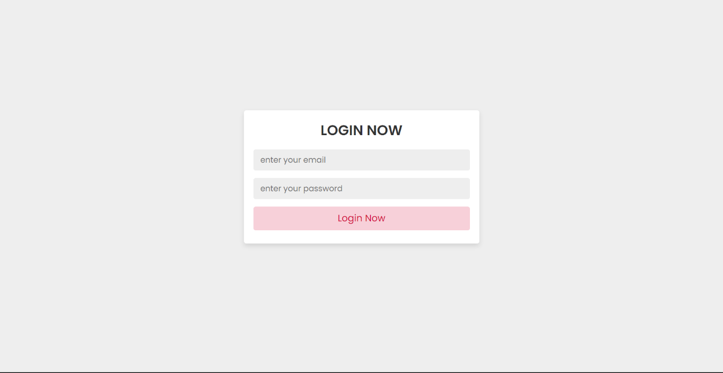

### GUI

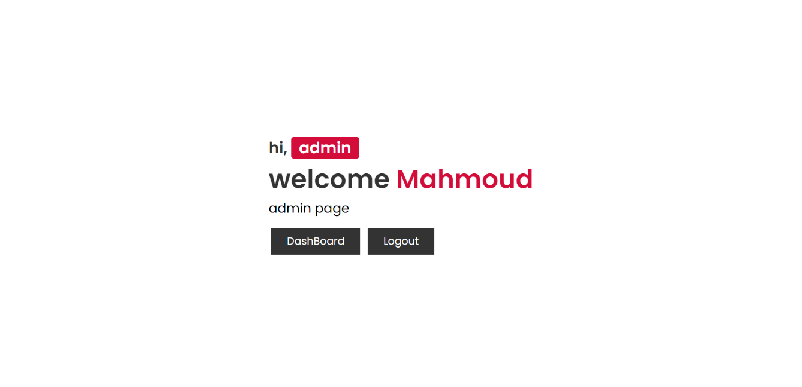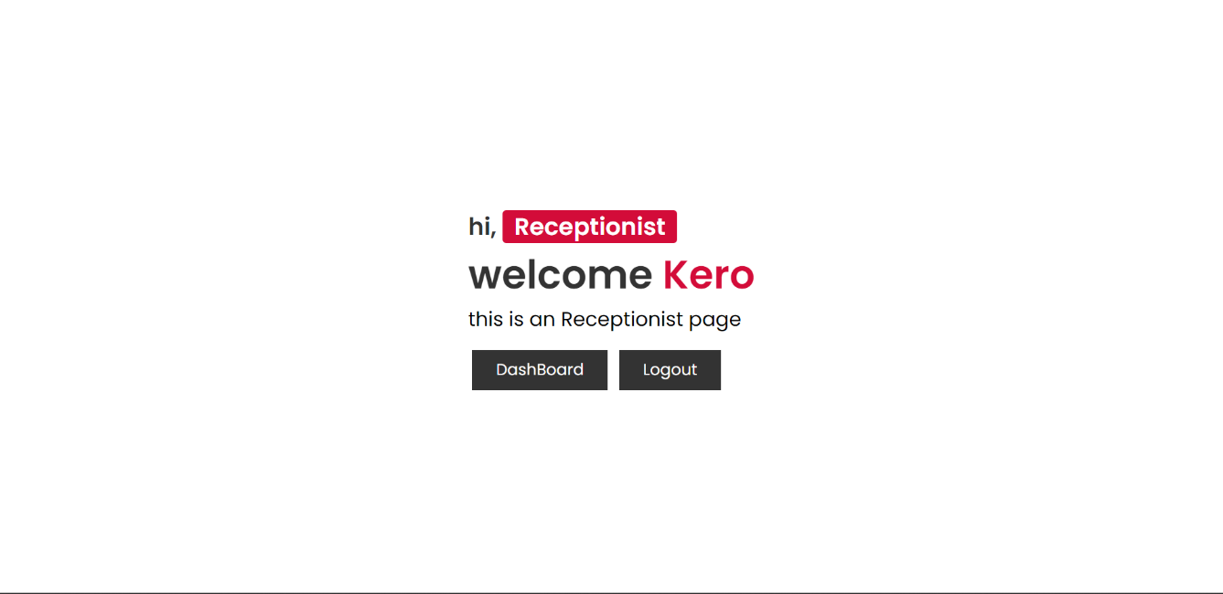

### CLI

none

### API

none

### Diagnostics or ROM

none

## Hardware Interfaces

none

## Communications Interfaces

none

## Software Interfaces

-Login Interface

-Admin Interface

-Receptionist Interface

-Warehouse Manager Interface

-Pharmacist Interface

# Performance Requirements

None.

# Design Constraints

## Standards Compliance

* 1. **Hardware Limitations**
  2. **others as appropriate**

# Other non-functional attributes

## Security

the system will have an encrypted information about the Sys users and no one can see it .

* 1. **Binary Compatibility**

## Reliability

* 1. **Maintainability**

## Portability

* 1. **Extensibility**

the system will be designed with a modular architecture that separates different components and functionality into distinct modules. This will make it easier to modify or extend specific parts of the system without affecting other components.

## Re-usability

## The orphan charity organization system will be designed with reusability in mind, so that it can be used by other organizations with similar needs or adapted to support different types of non-profit organizations.

* 1. **Application Affinity/Compatibility**

compatible with any operating system

## Resource Utilization

## The system architecture will be designed to minimize unnecessary processing and data storage. This will ensure that system resources are used efficiently.

* 1. **Serviceability**

the service that the software present it is available for all sys users

* 1. **others as appropriate**

# Preliminary Object-Oriented Domain Analysis

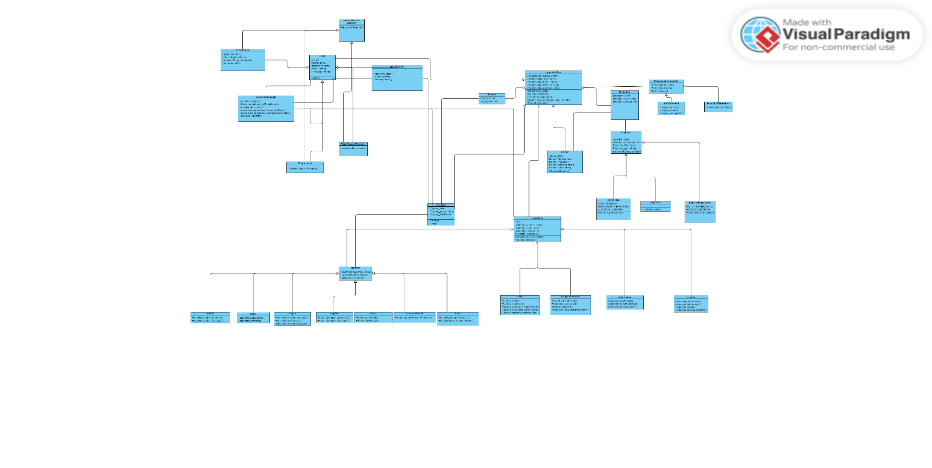

## Inheritance Relationships

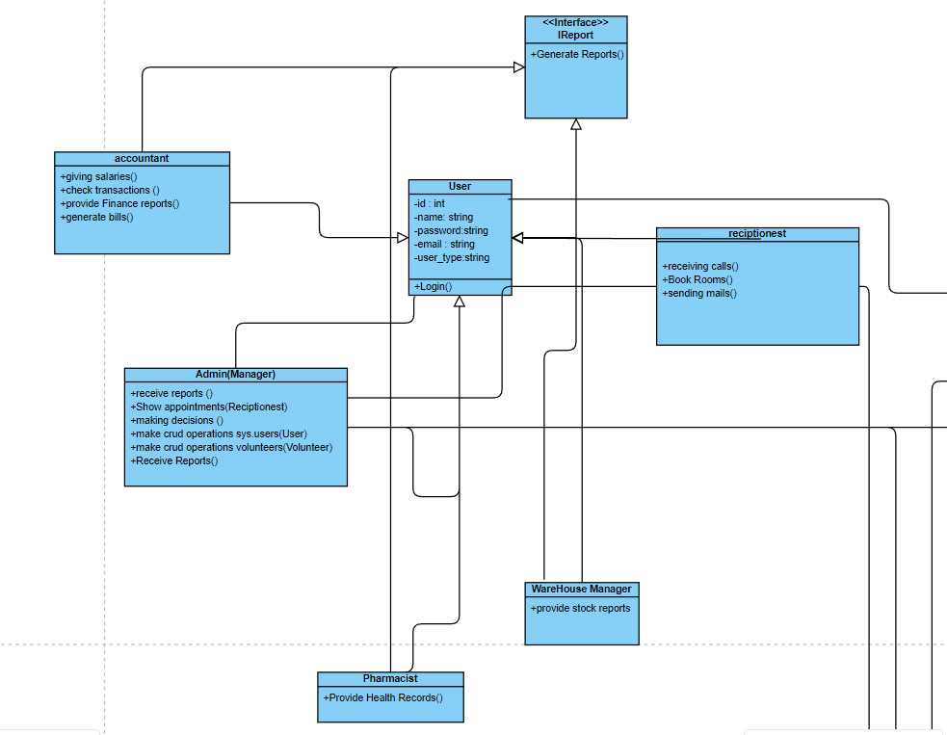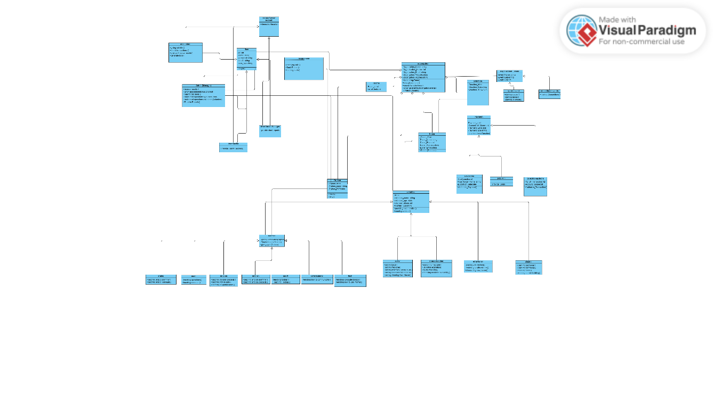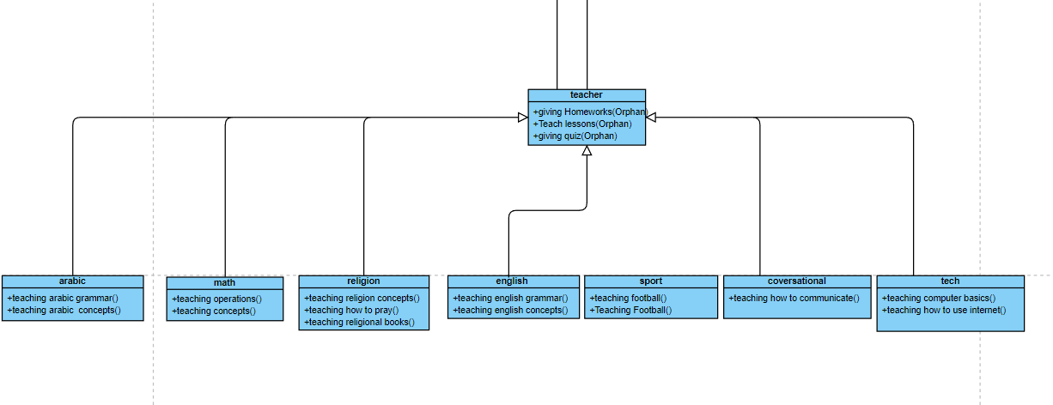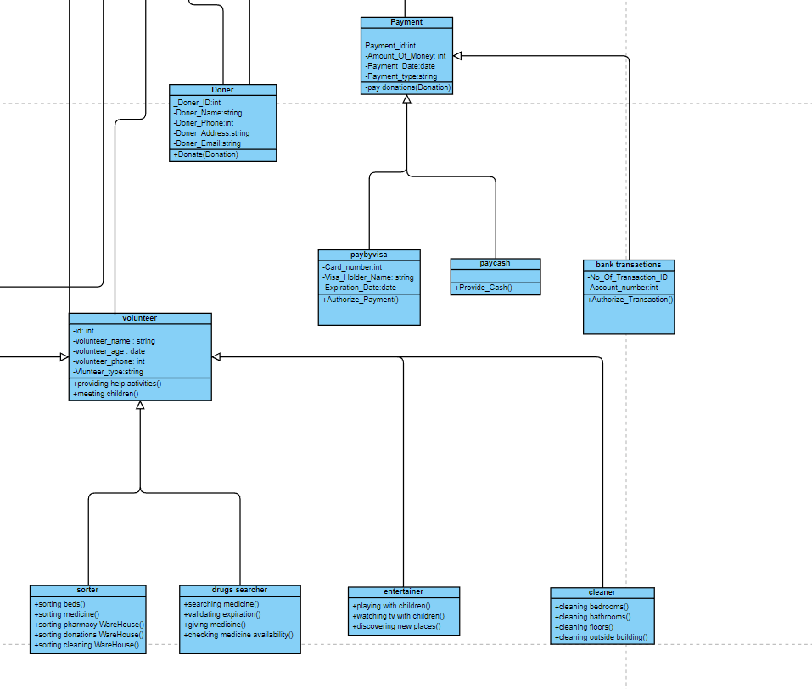

## Class descriptions

This section presents a more detailed description of each class identified during the OO Domain Analysis. For more details on the process giving rise to these descrip- tions, see Lecture 5.3: OO Domain Analysis and/or texts on object-oriented software development. Each class description should conform to the following structure:

### Class name

Organization(Abstract class)

Organizational events(Abstract Class)

Volunteer(Abstract Class)

Orphan(Abstract Class)

User(Concrete Class)

Admin(Concrete Class)

Reciptionest(Concrete Class)

Pharmacist(Concrete Class)

WareHouse Manager(Concrete Class)

Accountant(Concrete Class)

Doner(Concrete Class)

Payment(Concrete Class)

Pay by Visa(Concrete Class)

Pay by Cash(Concrete Class)

Bank transfer(Concrete Class)

### List of Superclasses:

1-Organizational events

2-Payment

3-Volunteer

4-Teacher

5-User

### List of Subclasses:

1-Sports events

2-Educational events

3-Pay by visa

4-Pay by cash

5-Bank transactions

6-Sorter

7-Drug searcher

8-Cleaner

9-Entertainer

10-Admin

11-Pharmacist

12-Accountant

13-Reciptionest

14-Warehouse Manager

### Purpose:

staff classes(Warehouse manager ,accountant, receptionist,manager): the purpose of this classes is to make their work which is to take care of Orphans or making an ap- pointment for them

### Collaborations:

Reciptionest with manager

Warehouse with manager

Pharmacist with manager

Accountant with manager

Accountant with doner

Voulnteer with organization

### Attributes:

Reciptionest with manager:

Needs appointments details

Warehouse with manager:

Needs report details

Pharmacist with manager:

Needs report details

Accountant with manager:

Needs report details

Accountant with doner:

Needs Donation details

Voulnteer with organization :

Needs Volunteer details

### Operations

: Lists each operation that can be invoked upon instances of this class. For each operation, the arguments (and their type), the return value (and its type), and any side effects of the operation should be specified.

### Constraints:

# Operational Scenarios

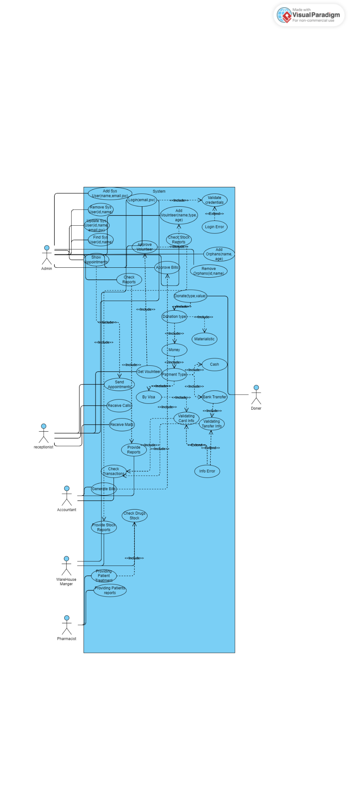

# Preliminary Schedule Adjusted

- Tasks were prioritized based on their importance and urgency

-The project team regularly monitors progress and adjusts the schedule as needed to ensure that the project is completed on time.

- The project team will work collaboratively to ensure that all tasks are completed on time and to a high standard of quality.

# Preliminary Budget Adjusted

This section provides an initial budget for the project, itemized by cost factor.

# Appendices

Specifies other useful information for understanding the requirements. All SRS documents should include at least the following two appendices:

## Definitions, Acronyms, Abbreviations

Provides definitions of unfamiliar definitions, terms, and acronyms.

* 1. **Collected material**

# References References

[1] M. Rehm, N. Bee, and E. Andre, “Wave like an egyptian: accelerometer based

gesture recognition for culture specific interactions,” in *Proceedings of the 22nd British HCI Group Annual Conference on People and Computers: Culture, Cre- ativity, Interaction - Volume 1*, ser. BCS-HCI ’08. Swinton, UK, UK: British Computer Society, 2008, pp. 13–22.